Report for Assignment 1

Xianghang Mi

[xmi@iu.edu](mailto:xmi@iu.edu)

# Abstract

In this project, I implemented several http servers and clients with different features, such as persistent connection and multiple threads. Detailed description of those implementations is in Section 2, where you can also find out how to use those servers and clients. To test performance, availability and difference of those servers and clients, I did several experiments whose results are listed in Section 3.

# Implementation and Use

## Implementation

I implemented three different http server and two http clients, the difference of them is listed in Figure 1 as below.

|  |  |  |  |  |  |
| --- | --- | --- | --- | --- | --- |
| Name | Type | Description | Multi -thread | Persistent connection | Underlying Protocol |
| mttserver | http server | Multi-thread TCP-based server | yes | yes | TCP |
| tcpserver | http server | TCP-based server | no | yes | TCP |
| udpserver | http server | UDP-based server | no | no | UDP |
| tcpclient | http client | TCP-based server | no | yes | TCP |
| udpclient | http client | UDP-based client | no | no | UDP |

Figure list of HTTP servers and clients

## How to use them

1. Compile them

In the project root directory, run “./run”, which will compile the source code, after finishing it,

Go to “bin” directory where you can find compiled executables: mttserver, tcpserver, udpserver, tcpclient, udpclient.

1. Run them

From the README file in the root directory, you can find instructions of how to run those executables.

# Experiments

## Compare the performance of persistent TCP connection and non-persistent TCP connection

Just as showed in Figure 2 and Figure 3, when we use TCP persistent connection to transfer multiple 1MB files, the average time cost for each file is 20,000 microseconds less than using no-persistent connection

|  |  |  |  |  |  |  |
| --- | --- | --- | --- | --- | --- | --- |
| Client Type | Server Type | Persistent | File Size(Bytes) | File count | overall time cost | time cost per file |
| TCP | TCP Server | p | 1,094,328 | 10 | 1,143,924 | 114,392 |
| TCP | TCP Server | p | 1,094,328 | 10 | 1,156,637 | 115,664 |
| TCP | TCP Server | p | 1,094,328 | 10 | 1,186,649 | 118,665 |
| TCP | TCP Server | p | 1,094,328 | 10 | 1,163,795 | 116,380 |
| TCP | TCP Server | p | 1,094,328 | 10 | 1,165,122 | 116,512 |
| TCP | TCP Server | p | 1,094,328 | 10 | 1,159,622 | 115,962 |
| TCP | TCP Server | p | 1,094,328 | 10 | 1,166,134 | 116,613 |
| TCP | TCP Server | p | 1,094,328 | 10 | 1,132,527 | 113,253 |
| TCP | TCP Server | p | 1,094,328 | 10 | 1,140,322 | 114,032 |
|  |  |  |  | 90 | 10,414,732 | 115,719 |

Figure . persistent TCP-based file transfer

|  |  |  |  |  |  |  |
| --- | --- | --- | --- | --- | --- | --- |
| Client Type | Server Type | Persistent | File Size(Bytes) | File count | overall time cost | timecost per file |
| TCP | TCP Server | no | 1,094,328 | 1 | 142,493 | 142,493 |
| TCP | TCP Server | no | 1,094,328 | 1 | 130,789 | 130,789 |
| TCP | TCP Server | no | 1,094,328 | 1 | 119,389 | 119,389 |
| TCP | TCP Server | no | 1,094,328 | 1 | 140,711 | 140,711 |
| TCP | TCP Server | no | 1,094,328 | 1 | 109,982 | 109,982 |
| TCP | TCP Server | no | 1,094,328 | 1 | 139,809 | 139,809 |
| TCP | TCP Server | no | 1,094,328 | 1 | 152,750 | 152,750 |
| TCP | TCP Server | no | 1,094,328 | 1 | 138,732 | 138,732 |
| TCP | TCP Server | no | 1,094,328 | 1 | 154,595 | 154,595 |
|  |  |  |  | 9 | 1,229,250 | 136,583 |

Figure . no-persistent TCP-based file tranfer

## UDP-based Http server and client

1. Compare data in Figure 2, 3, 4, we can conclude that without overhead of connection establishment, UDP can larges improve the performance of transferring files of same size.
2. However, from Figure 4, we can see data loss of UDP, So comparing with TCP, UDP can provide improved performance at overhead of data loss.

|  |  |  |  |  |  |  |  |
| --- | --- | --- | --- | --- | --- | --- | --- |
| Client Type | Server Type | Persistent | File Size(Bytes) | File count | time cost | recved bytes | loss rate |
| UDP | UDP | no | 1,094,328 | 1 | 75,581 | 328,281 | 0.30 |
| UDP | UDP | no | 1,094,328 | 1 | 97,299 | 924,883 | 0.85 |
| UDP | UDP | no | 1,094,328 | 1 | 90,642 | 1,040,306 | 0.95 |
| UDP | UDP | no | 1,094,328 | 1 | 102,120 | 1,094,328 | 1.00 |
| UDP | UDP | no | 1,094,328 | 1 | 100,482 | 972,909 | 0.89 |
| UDP | UDP | no | 1,094,328 | 1 | 89,653 | 1,094,328 | 1.00 |
| UDP | UDP | no | 1,094,328 | 1 | 69,602 | 415,223 | 0.38 |
| UDP | UDP | no | 1,094,328 | 1 | 92,302 | 1,076,340 | 0.98 |
| UDP | UDP | no | 1,094,328 | 1 | 83,697 | 944,428 | 0.86 |
| UDP | UDP | no | 1,094,328 | 1 | 109,917 | 881,470 | 0.81 |
|  |  |  | 1,094,328 |  | 91,130 | 877,250 | 0.80 |

Figure UDP-based file transfer

## Wireshark packets profile

From Figure 5 and 6, we can see the TCP connection between client and server, UDP packets between UDP-based client and server.

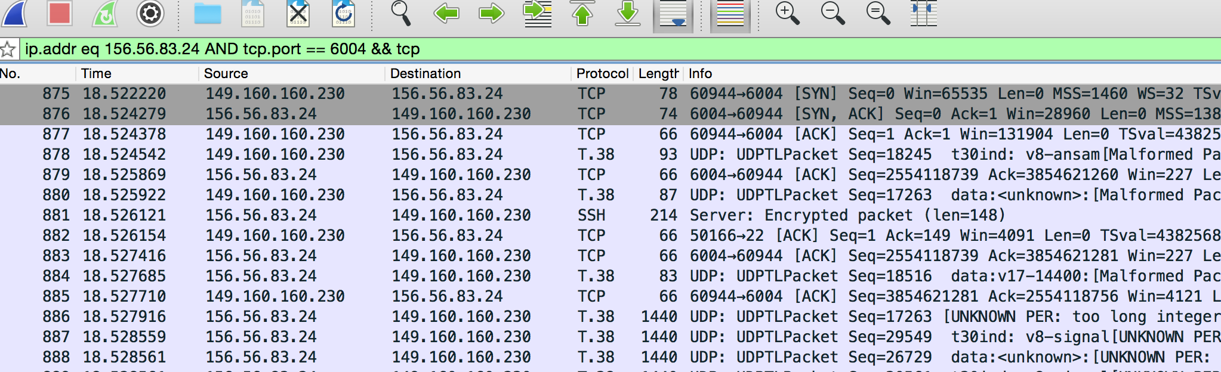

Figure . TCP packets between TCP server and client

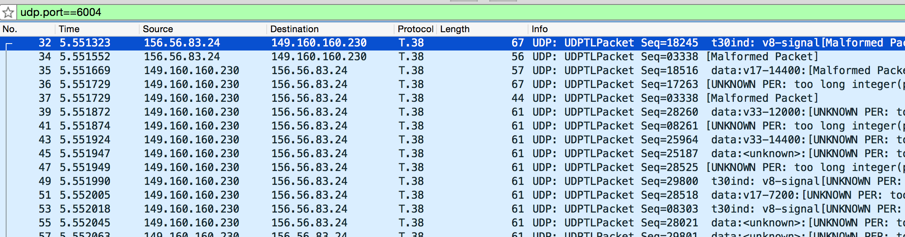

Figure . UDP packets between UDP server and client